USE CASE 1. CREATE AND MAINTAIN AN IDENTITY
When you onboard an employee or contractor at your agency, you will collect identity information from the individual and store parts of that information as identity attributes. These attributes serve as a digital proxy for the individual’s identity, also known as an enterprise identity. | 

Use Case
In this use case, an administrator needs to collect or manage identity data for an employee or contractor for the purpose of creating an enterprise identity record and maintaining it throughout its lifecycle.
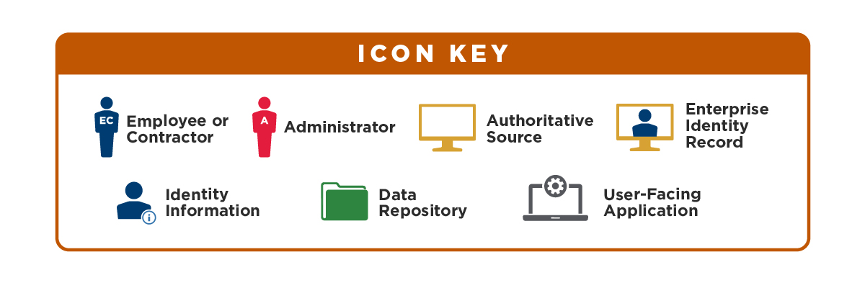
- Collect Information | The administrator collects identity information from the employee or contractor.  This identity may come from the individual, onboarding documents, or HR systems.


- Create an Enterprise Identity | The administrator adds the identity information to the authoritative source, a data repository.  Result: An enterprise identity in the authoritative source for the employee or contractor.

- Maintain the Enterprise Identity | The following steps describe identity maintenance your agency should perform on a regular basis.
3a. Identify and Aggregate Identity Data | Query your data repositories for any existing identities for an individual. Aggregate these attributes as single enterprise identity for the individual.  If an individual has updated personal information, there are two ways to update the enterprise identity:

3b. Update the Enterprise Identity | - The administrator updates the individual’s enterprise identity attributes directly in the authoritative sources.  - The individual uses an agency application to update their personal information, and the application updates the individual’s enterprise identity attributes in the authoritative sources.
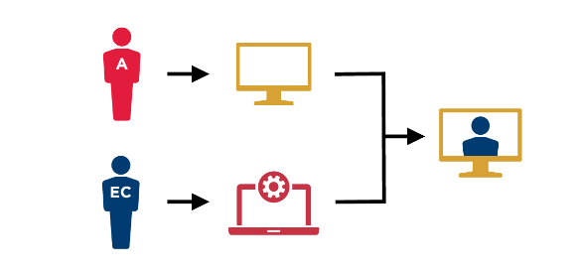
3c. Delete the Enterprise Identity | When you need to delete an enterprise identity, delete the identity attributes in the authoritative source.


EXAMPLE
You want to create a new enterprise identity so that an individual may be established as a federal employee or contractor that will need to be identity proofed, credentialed, and granted access to agency services.

USE CASE 2. PROOF AN IDENTITY
Before you can create a credential and assign it to an individual, that person must first provide proof of their claimed identity. Identity proofing is the process by which a federal agency collects and verifies information about a person to establish an enterprise identity.
The location or information that a person needs to access informs the Identity Assurance Level (IAL), which determines the elements you should require from that person for identity proofing. There are three IALs; however, federal agencies requires a minimum of IAL2 for employees or contractors with recurring access to government resources, so these use cases do not include IAL1.

